1.
- $n_{n}=N_{D}$
$p_{n}=\frac{n_{i}^{2}}{N_{D}}$ [4]
Bookwork & standard question

- For the probability, take the Fermi distribution function (equation sheet) at E = E_{F}. [2]
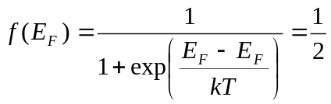
ii) In order to have an electron at E = E_{F} there must be an available state. Since E = E_{F} is in the bandgap and the bandgap does not have states (energy levels), there can be no electron at E_{F}.
Note: if the doping is degenerate, E_{F} is in the conduction band and then an electron can be found at the energy value. [4]
Definition of Fermi level

- [4]
N_{D}(x)
L
x
N₁
N₂
E
+
-

(2)

Due to the gradient in doping density there will be a gradient in electron concentration. Therefore electrons will diffuse from high concentration (x=0) to low concentration (x=L). When no bias is applied, no net current is flowing, therefore there must be an internal electric field that causes an electron flux in the opposite direction. The direction of the electric field is from + to -, the electrons move to + via drift, opposite to the diffusion direction.
(2)
Mostly OK but a few did not realise that current is zero and thus diffusion and drift are compensated. This led to some weird explanations: “e.g. more negative where there are more electrons and then putting a –ve at that side”, which is wrong.

- Once we know the electric field, we know that it points towards increasing potential energy. Or we can say, we know that the electrons drift from right to left therefore the potential energy right needs to be higher than that at the left. You can also look at the concentration of carriers, must be lower at the right than at the left of the energy band diagram. [6]
Since it is n-type, E_{F} must lie above E_{i} over the whole length. E_{G} must remain constant and E_{F} too (no bias).
E_{C}
E_{F}
E_{i}
E_{V}
E_{G}

Major error in this question is to have a slope in EF. One of the basic principles of energy bands of semiconductor devices is that the Fermi level is constant when no external bias is applied.
In principle the potential energy varies non-linearly as can be derived from the Poisson equation:
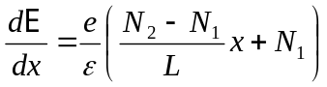
However, this has not been considered for a good answer, answer is accepted as long as the slope is consistent with the electric field.

- In order to have an ohmic contact, there must be accumulation of the majority carriers as the junction between semiconductor and metal. Thus the energy band diagram must look like: (4)
E_{C}
E_{F}
E_{V}
E_{G}
χ_{Si}
φ_{Si}
φ_{m}

To achieve this, electrons have to diffuse from the semiconductor to the metal, thus the work function of the metal needs to be larger than the workfunction of the semiconductor.
Calculation of the workfunction of the semiconductor:
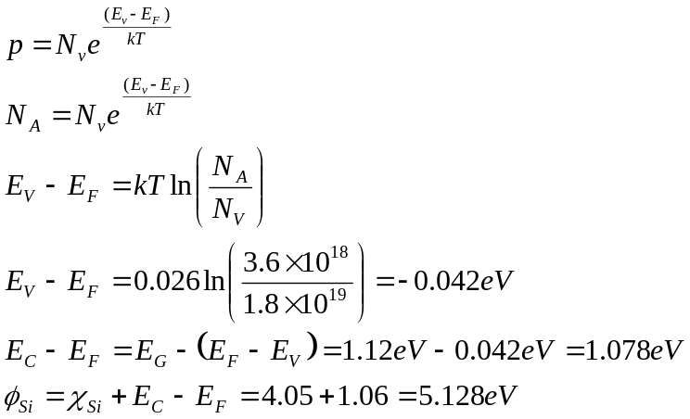(4)
Thus, there is no metal available in the table that can be used to make an Ohmic contact on p-Si with this doping density because all the metal workfunctions are smaller than that of the p-Si material. (2) [10]

A common question in exams, therefore it is here presented with a twist to check critical analysis. Some students were confused as there are no metals that will give an Ohmic contact. This question is different in the sense that you have to be critical (engineering skill) and state that none are appropriate. Some students suggested W as it is the closest to the requirement. That was accepted as answer as it is a critically analysed choice.
However marks are given on definition of workfunction relation and the derivation of the workfunction for Si. There were many errors against the workfunction relation though.

- Relevant formulae from the formulae sheet in the p-type depletion region are: [6]

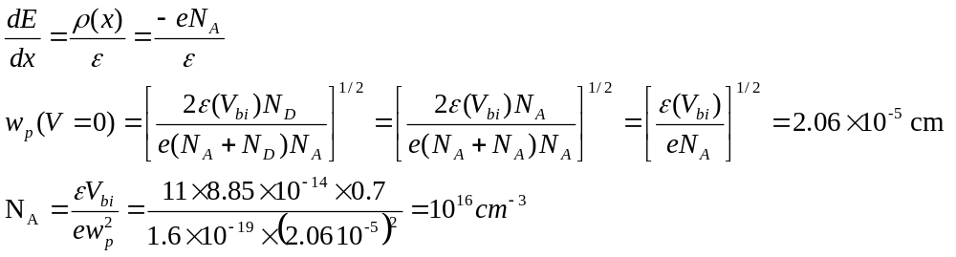
The maximum electric field occurs as x=0. We also know that E(x)=0 at x=-w_{p}.

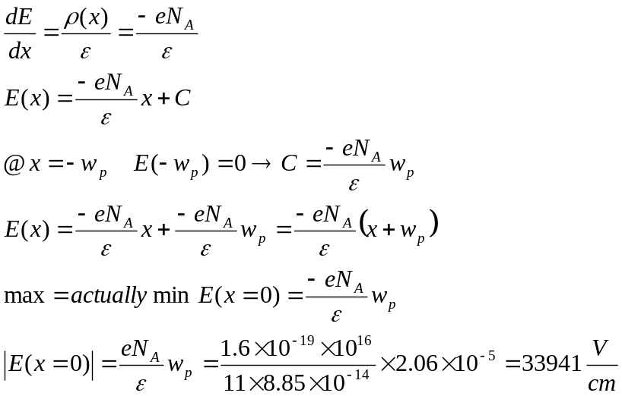

This question can be solved in other ways. Common problems were in the use of the dielectric: e = e0 × er and using the correct dimensions (cm or m but not a mixture of the two). The other error was using the relationship J_{n} = 0. This is not an appropriate method in a diffusion type device. Many people filled in value immediately instead of first looking for a suitable expression. The easiest expression that can be found (not shown above) is:
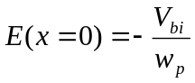
You have to know that maximum electric fields occur at the junctions, this is where devices will break down (e.g. power electronics).

n+

n+
p

S
D
G

B
- . [4]
There is a slightly larger
depletion width at drain side

Most common mistake is drawing an inversion layer & drawing energy band diagrams without defining the depletion regions.
2.
- Since it is an nMOS, we use the expression for the electron current density: [10]
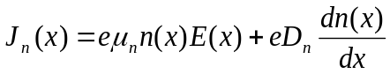 (2)
Drift current (3)
The first term is the drift term, the second one is diffusion.
E(x) is related to the applied voltage between source and drain V_{DS}.
n(x) is the charge in the channel at each position x, proportional to V_{GS} –V_{th} – V(x) ≈ V_{GS} –V_{th} (triode region: small V_{DS}, strong inversion: large V_{GS}>>V_{th}). Thus n(x) is large in strong inversion. Note that as a result only a small density of holes can be present in the channel. Therefore, drift of holes is negligible.
Diffusion current (5)

n+

n+
p

S
D
G

B
In order to look at diffusion, we need to compare the carrier concentration near the source to that near the drain. See material cross section →
The electron concentration in the channel is determined by the voltage across the oxide at each position x in the channel, thus V_{GS} near the source and V_{GD} near the drain.
The figure with the energy band diagram shows how this voltage determines the distance between E_{c} and E_{F} and thus the electron concentration following equation:
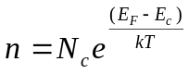.
First we observe that V_{GD} = V_{GS} – V_{DS} and that V_{DS} is small as it is in the triode region. V_{GS} is large because it is strong inversion. Therefore, V_{GD} ≈ V_{GS}. The applied gate voltage is dropped partially across the oxide and partially across the semiconductor. Therefore since V_{GD} ≈ V_{GS} the difference in voltage drop across the semiconductor-only will also be very small. This is plotted in the energy band diagram where the band bending difference between both cases at the oxide/semiconductor interface is small. Thus E_{c}-E_{F} near this interface will be approximately the same in both case. This will give a small gradient of electron concentration between source and drain and thus a small diffusion current.
Since drift is large because the magnitude of n(x) is large, and diffusion is small because the concentration gradient is small, diffusion is neglected.

This was perceived as the most difficult question in the exam, it was also intended as a difficult question. The purpose is to check insight into the approximations that have been made to obtain simplified transport equations and how they can break down. The key parameter in the solution to this question is the realisation that the carrier concentration n is a function of x: n(x) and that the difference in n(x) between the source side and the drain side is determined by the voltage across the gate oxide, thus V_{GS} and V_{GD} respectively. There is obviously not possible answer, therefore insight was marked. Statements such as; “diffusion is neglected” without further explanations were not given any marks.

- Although diffusion in the channel is negligible, diffusion across the source-channel junction is important as this represents the control of the gate voltage on the current I_{DS}. (2) The energy band diagrams that need to be drawn are those from source through channel. Below is a drawing of the energy band diagram from source to drain for three different gate voltages, when no drain voltage is applied. This drawing shows that the potential barrier between the source and channel decreases with increasing gate voltage. (4) [10]
The height of the potential barrier V_{o} determines the density of carriers that is allowed to diffuse from the source into the channel. The electrons in the source have an energy that is determined by the Fermi distribution. Only those electrons that have an energy higher than eV_{o} can diffuse across the barrier and then become available for drift through the channel. This is illustrated in the next diagram.
The concentration of electrons as a function of energy together with a potential barrier is given in the figure above. Only those electrons above the potential barrier can diffuse, the ones below cannot diffuse as they would end in the forbidden band. Lowering the barrier V_{o} lets more electrons across. (4)

This was done in the study groups and is presented in the video recordings.

The relationship between Q and V is via C: C=Q/V or Q=CV [6]
For a MOSFET this becomes Q_{channel} = C_{ox} V_{across oxide} (2)
V_{across oxide} is the difference between the potential on the gate and the potential in the channel. The potential in the channel changes in each point in the channel between source and drain due to the application of V_{DS}. In addition, it is postulated that no inversion charge is available for V_{GS}<V_{th} thus charge can only appear for V_{GS} – V_{th} > 0.
Thus 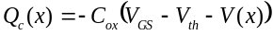. The sign for V(x) is negative because there will be less inversion for higher V_{DS}. (4)

ii) 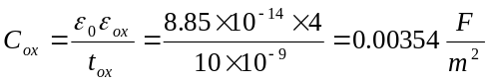. V(x) halfway the channel is approximately V_{DS}/2=0.05V, assuming a linear variation of V(x) between source and drain.
[4]

This is actually bookwork as it is related to the derivation of the drift current in MOSFETs. This was done in the powerpoint presentation, in the recording and in the textbook. Of course there we concentration on n(x) rather than on Q(x). For part ii) marks were given for correctly calculating C_{ox} which is a capacitance per gate area.
3.
a) . [10]
In forward active mode E_{F} in emitter is increasing compared to E_{F} in base (forward bias) while E_{F} in collector is decreasing compared to E_{F} in base (reverse bias). The potential barriers should change accordingly. (3)
E_{c} is closer to E_{F} in emitter than in collector and E_{c}-E_{F} in collector is approximately the same as E_{F}-E_{v} in base. This represents the correct doping. (3)
Depletion widths should extend in the lowest doped regions and the total depletion width in forward bias must be smaller than that in reverse bias. (3)
All symbols need to be given on the drawing to define the different lines. (1)

Solved in the recordings. Main error was the occurrence of a slope in the base. BJT: diffusion transport -> only slope across the junctions.

b) excess minority carrier concentration: thus no excess at Ohmic contacts (2). In emitter at E-B junction: Δp’_{n} = p’_{n}-p_{n0}, in base at same junction: Δn’_{p} = n’_{p}-n_{p0} (2) In collector at B-C junction: Δp”_{n} = p”_{n}-p_{n0}, in base at same junction: Δn”_{p} = n”_{p}-n_{p0} (2). ‘ is forward bias value (V>0) and “ is reverse bias value (V<0) in 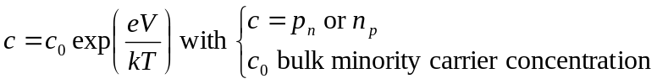. [10]

Note: all lines are linear (1). Δp’_{n} < Δn’_{p} because emitter is more heavily doped. Δp”_{n} = Δn”_{p} and are both negative because it is reverse bias (2). Excess carriers need to be zero at the contacts. The excess carrier concentrations should start at the edge of the depletion regions (1).

Main mistake were the values of the deficit carrier concentration at the reverse bias BC junction. Another classical mistake is to draw the carrier concentration rather than the excess carrier concentration.
c) . [6]
i)
$$J_{E}=-\frac{eD_{n}{Δn}_{p}^{'}}{W_{B}}-\frac{eD_{p}{Δp}_{n}^{'}}{L_{E}}$$
$$J_{C}=-\frac{eD_{n}{Δn}_{p}^{'}}{W_{B}}-\frac{eD_{p}{|Δp}_{n}^{"}|}{L_{C}}$$
$$J_{B}=J_{E}-J_{C}=-\frac{eD_{p}{Δp}_{n}^{'}}{L_{E}}+\frac{eD_{p}|{Δp}_{n}^{"}|}{L_{C}}$$
In this derivation we have ignored Δn”_{p} at the base-collector junction as it value is negligible compared to Δn’_{p.}

Major weakness observed in solving this question is where students revert to the pn diode current equations given in the formulae sheet. This is not very efficient in view of the answer given in b) and the fact that all minority carrier variation gradients are linear. This has led to mistakes in voltages in the exponential V_{EB} or V_{BC} and in material lengths rather than diffusion lengths. It also led to errors in sign of the leakage current.

- [4]
Without leakage:

$$β=\frac{I_{C}}{I_{B}}=\frac{\frac{D_{n}{Δn}_{p}^{'}}{W_{B}}}{\frac{D_{p}{Δp}_{n}^{'}}{L_{E}}}$$
With leakage:
$$β=\frac{{I'}_{C}}{{I'}_{B}}=\frac{\frac{D_{n}{Δn}_{p}^{'}}{W_{B}}+\frac{D_{p}{|Δp}_{n}^{"}|}{L_{C}}}{\frac{D_{p}{Δp}_{n}^{'}}{L_{E}}-\frac{D_{p}{|Δp}_{n}^{"}|}{L_{C}}}=\frac{I_{C}+I_{L}}{I_{B}-I_{L}}$$
With leakage I_{C} increases and I_{B} decreases compared to without leakage, thus β increases when the collector leakage current from collector into base is taken into account. I_{L}: leakage current.

Lots of tricks were played in order to ensure that β increased with leakage. However if ii) answer not consistent with i) answer then no marks allocated. If ii) consistent with i) then marks allocated.

